Lesson 3: Translating Lines

Classwork

Exercises

1. Draw a line passing through point *P* that is parallel to line $L$. Draw a second line passing through point $P$ that is parallel to line $L$, that is distinct (i.e., different) from the first one. What do you notice?

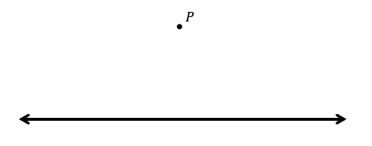

1. Translate line $L$ along the vector $\vec{AB}$. What do you notice about $L$ and its image $L'$?

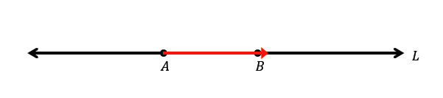

1. Line $L$ is parallel to vector $\vec{AB}$. Translate line $L$ along vector $\vec{AB}$. What do you notice about $L$ and its image, $L'$?

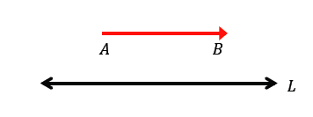

1. Translate line $L$ along the vector $\vec{AB}$. What do you notice about $L$ and its image, $L'$?

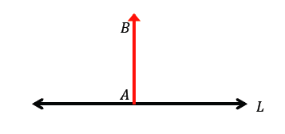

1. 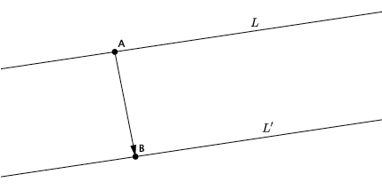Line $L$ has been translated along vector $\vec{AB}$ resulting in $L’$. What do you know about lines $L$ and $L’$?
2. Translate $L_{1}$ and $L_{2}$ along vector $\vec{DE}$. Label the images of the lines. If lines $L_{1}$ and $L_{2}$ are parallel, what do you know about their translated images?

Macintosh HD:Users:Stefanie:Dropbox:Module 2:Lesson 4 images:transparalllinestudent.pdf

Lesson Summary

* Two lines are said to be parallel if they do not intersect.
* Translations map parallel lines to parallel lines.
* Given a line *L* and a point $P$ not lying on $L$, there is at most one line passing through $P$ and parallel to $L$.

Problem Set

1. Translate $∠XYZ$, point $A$, point $B$, and rectangle $HIJK$ along vector $\vec{EF}$ Sketch the images and label all points using prime notation.

Macintosh HD:Users:Stefanie:Dropbox:Module 2:Lesson 4 images:translate rect point angle1.pdf

1. What is the measure of the translated image of $∠XYZ$. How do you know?
2. Connect $B$ to $B'$. What do you know about the line formed by $BB'$ and the line containing the vector $\vec{EF}$?
3. Connect $A$ to $A'$. What do you know about the line formed by $AA'$ and the line containing the vector $\vec{EF}$?
4. Given that figure $HIJK$ is a rectangle, what do you know about lines $HI$ and $JK$ and their translated images? Explain.